Title

[Make a title concise and inviting]

First Author1*, Second AuthorX, Middle Author(s)X, Senior CollaboratorX, Last Author1

1Department of Biophysics, Donders Institute for Brain, Cognition and Behavior, Radboud University, Nijmegen, The Netherlands

2Department of Otorhinolaryngology, Donders Institute for Brain, Cognition and Behavior, Radboud University Medical Center, Nijmegen, The Netherlands

*e-mail: firstname.lastname@donders.ru.nl

[If you are student/intern, please indicate your study program (e.g. Medical Biology), BSc vs MSc, learning trajectory or specialization if possible, year, length of internship (time and EC) instead of affiliation]

## ORCID iD

FA: https://orcid.org/XXXX-XXXX-XXXX-XXXX

Marc M. van Wanrooij: https://orcid.org/0000-0003-4180-1835

[Students can skip ORCID]

[Decide where to submit to. This decision determines – to a small extent - the format of the paper and the amount of jargon you can use.

A nice AI tool to make this decision for you…: <https://jane.biosemantics.org/> ]

## Data availability

All code used for all analyses and plots are publicly available on GitLab at <https://gitlab.science.ru.nl/marcw/biofysica>

The data have been deposited in the Donders Institute for Brain, Cognition and Behavior Data Repository at https://doi.org/XX.XXXX/XXXX-XXXX

[Student: your code and data should be available to your supervisors, e.g. on the mbaudit drives.]

## Funding

This study was supported by the Netherlands Organization of Scientific Research, NWO-MaGW Talent Grant No. 406-14-025 (to F.A.), Horizon 2020 ERC Advanced Grant “Orient,” No. 693400 (to S.C.), and by the Radboud University (to L.A.).

[Student: ask your supervisors]

## Acknowledgements

We thank Günter Windau, Ruurd Lof, and Stijn Martens for valuable technical assistance and Helpful Collaborator for feedback on the manuscript.

## Author contributions

[More and more journals ask for credit assignment. Here are some nice tools:

<https://casrai.org/credit/>

<https://martonbalazskovacs.shinyapps.io/tenzing/>

Who can be an author? Guidelines are provided here:

<http://www.icmje.org/recommendations/browse/roles-and-responsibilities/defining-the-role-of-authors-and-contributors.html#two>

From <https://kosslynlab.fas.harvard.edu/files/kosslynlab/files/authorship_criteria_nov02.pdf>:

The key to fair allocation of authorship, and equitable ordering, is to have criteria that are known to all and that all can discuss. It is best to walk through each of these criteria at the outset of the project. Expectations should be clear (which role someone plays in the project, and how much effort that person should expend). Everyone should assess their contribution after the project is relatively complete but before the paper is written.]

F.A. and M.W. conceived of the experiment(s) and developed the analyses. F.A. wrote the analysis code and analyzed the data. S.A. and M.A. analyzed the specialty data. S.C. provided data and advised analyses. F.A. and M.W. wrote the manuscript, and all authors edited the manuscript.

[Student: it is important to realize what needs to be done in order to publish a paper. Also, you collaborate in a team and you will not do everything independently. Therefore, you should fill out this Author Contribution section as well. Note the requirements for an internship (designing, experimenting, analyzing, writing). ]

Competinginterests. the authors declare no competing interests.

[Structure your paper well (Mensh and Kording 2017): <https://journals.plos.org/ploscompbiol/article?id=10.1371/journal.pcbi.1005619>]

[Writing will help you organize, formalize, and invent your ideas (Sarnecka 2019), <https://osf.io/n8pc3/>

Tips:

* Write regularly
* Schedule daily 1-hour writing (and write, even without inspiration)
* Write like a ninja (whenever you have time, write for a few minutes)]

[Currently, new AI tools are being developed that may help you improve your paper. For example:

<https://paperpal.com/>

<https://openai.com/blog/chatgpt/>

<https://galactica.org>

An example on how to prompt can be (Stokel-Walker and Van Noorden 2023):

“Revise the following paragraph from the introduction or an academic paper (with the title ‘…’ and keywords “…”) so most of the citations to other academic papers are kept, the text minimizes the use of jargon, the text grammar is correct, spelling errors are fixed, and the text is in active voice and has a clear sentence structure.”

]

# Abstract

[The [Nature guidelines](https://drive.google.com/file/d/1GYegb4V9udx3g-4OJSAkvrkrwN7T8Rum/view?usp=sharing) (<https://www.nature.com/documents/nature-summary-paragraph.pdf> ) on writing a good abstract are very useful here, and what we use in the structure below.]

[Use Headings (in Word in Styles pane). Include subheadings in Methods, Results, and Discussion. No numbering of sections. Do not end with period or colon. No line numbers. (if needed for journal layout, these can be easily adjusted)]

[Preferably, text should be aligned according to “Justify text”.]

[NEVER, EVER use abbreviations!!! They only make it harder to read the text (exceptions exist, e.g. deoxyribonucleic acid).]

One or two sentences providing a basic introduction to the field, comprehensible to a scientist in any discipline.

Two to three sentences of more detailed background, comprehensible to scientists in related disciplines.

One sentence clearly stating the general problem being addressed by this particular study.

One sentence summarizing the main result (with the words “here we show” or their equivalent).

Two or three sentences explaining what the main result reveals in direct comparison to what was thought to be the case previously, or how the main result adds to previous knowledge.

One or two sentences to put the results into a more general context.

Two or three sentences to provide a broader perspective, readily comprehensible to a scientist in any discipline.

[You should spend a large proportion of your time on writing and rewriting your abstract. Start also with writing an abstract! This is a draft version (i.e. you do not have results yet), but writing up your research question, experimental paradigm, and hypotheses in a succinct way, can help you focus on a single, clear story. This is an iterative process. Whenever you change your paradigm, come up with a better hypothesis, or have your results come in, you should adjust the relevant sections of your abstract. Then, when you have finished your pilot experiments and start with your main experiment, your abstract is basically ready. You then only need to update the actual results and conclusions.]

## Keywords

[About 5 keywords should accompany the abstract. They should not include words in the title. and should, if possible, be drawn from the MeSH list of Index Medicus and be chosen with a view to useful cross-indexing of the article.

MesH on-demand tool: <https://meshb.nlm.nih.gov/MeSHonDemand>]

Sound localization | Multisensory Integration | Cochlear Implant | Speech Recognition | Reaction Time | Pupillometry | Eye Tracking | Oculomotor Control | Vestibulo-Ocular Reflex | Smooth Pursuit | Bimodal Hearing | Psychophysics

# Introduction

[Begin with a historical background: where do the main ideas in the paper **come from**?]

[For literature references, use a reference manager (Zotero, Mendeley, EndNote)]

[Paragraphs: (Chapter 8, <https://osf.io/z4n3t>).

* Create tight, coherent paragraphs. Use hamburger paragraphs. Topic sentence, 1-N Supporting sentences, Conclusion sentence, maybe with transition sentence at beginning and end.
* Revise.
* Check information flow (topic chain, comment-topic chain, mixed chain.
* Use a different word if you refer to a different thing.
* Use the same word if you refer to the same thing.
* Make clear what a pronoun (this, that, they) is referring to.
* Complete the comparatives (higher, larger, better than …)
* Tip: Make use of signposting in drafts
* Remove unnecessary signposting

]

[The Heilmeier Catechism

<https://www.darpa.mil/work-with-us/heilmeier-catechism>

“DARPA operates on the principle that generating big rewards requires taking big risks. But how does the Agency determine what risks are worth taking? George H. Heilmeier, a former DARPA director (1975-1977), crafted a set of questions known as the "Heilmeier Catechism" to help Agency officials think through and evaluate proposed research programs.”

The first four need to be addressed in the introduction:

* What are you trying to do? Articulate your objectives using absolutely no jargon.
* How is it done today, and what are the limits of current practice?
* What is new in your approach and why do you think it will be successful?
* Who cares? If you are successful, what difference will it make?

]

[Par 1. Introduce the unsolved problem and clearly explain why it **is** a problem.]

Foo

[Par 2. How have others adressed this problem?]

Foo

[Par 3. To solve this problem, we have some clever new ideas, and here they are!]

Foo

[Par 4. Clearly state your hypotheses (the problem) and explain how your experiments will be able to dissociate between these.]

Foo

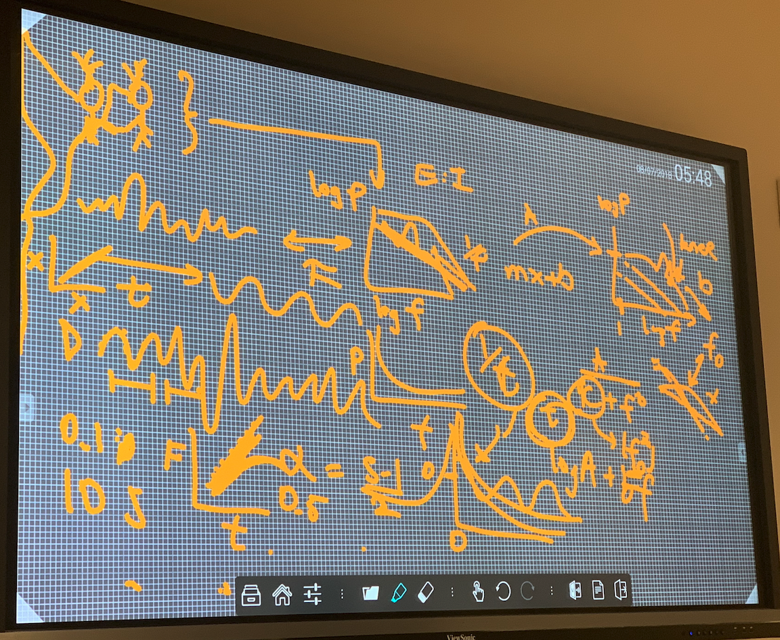

**Fig. 1| Rationale / Schematic of the study.** **a**, everything is awesome. **b**, also science is super cool.

[Use a concise, descriptive figure title.]

# Methods

[This section mostly writes itself, since you know what you did, and how you did it. Just be clear at every step along the way and point to code where applicable.

Describe the data sources: if human participants include ethical (METC/REC) approval information; if animal include DEC information; if publicly available summarize the data and link to them (data.donders.repository), including any special usage statements required by the data providers; if simulation, describe the simulation rationale, math, and code.

Examples are included below, to give you a good idea.]

[Units: SI units (or allowed ones), space between quantity and unit, e.g. 3.51 m/s. Note reasonable precision (numbers behind the decimal period): 3.146723 deg is unbelievable/impossible with our setups and human accuracy. For calculations, keep precision).]

## Human participants information

[Use “participants”, “listeners”, etc. (active), instead of “subjects” (passive). Do not use “patients” (as you, the researcher, are not treating them). Throughout the text, try to use “they” rather than he/she.]

## Ethics

The experiments were carried out in accordance with the relevant institutional and national regulations and with the World Medical Association Helsinki Declaration as revised in October 2013. The experiments were approved by [the Ethics Committee of Arnhem-Nijmegen / the Research Ethics Committee of the Faculty of Science of the Radboud University] (project number NLXXXXX.XXX.XX, Month DD, YYYY). All participants gave their written informed consent.

## Open data sources

## Task description

Foo

## Data analysis

All data were analyzed in Matlab (The Mathworks Inc., Natick, MA, USA). Additional analyses were performed using custom Matlab scripts, all of which are available on the laboratory GitLab account[1].

## Computing power spectral density (PSD)

## Data analysis

[Store your (preprocessed) data as tidy data. This will make data analysis and sharing easier. https://cran.r-project.org/web/packages/tidyr/vignettes/tidy-data.html]

# Results

## Behavioral

Foo

[Quantify! Do not state: this becomes larger. State: This increases by 0.2 [0.12, 0.23].]

[Figures. Figure resolution should be high. Use, for example, savegraph. Use vector-format (eps), which can be exported as png for insertion in document. Do not reshape figure. Label correctly. Font size should be readable. Use a legend when necessary. Number of figures: 6-10 is typical, with 1 rationale figure, 1 methods figure, 4-8 results figures, and potentially 1 Discussion figure.

[Tables. No. Zero. Never. (Most of the times). For data visualization, tables are terrible. For other researchers who are interested in exact numbers, sharing your data via an open repository is much better. To provide participant/‘patient’ etiology (age, gender, handedness, year of implantation, disease, etc), it is recommended to provide non-exact/vague types and ranges, rather than provide the information for every participant individually.]

## Electrophysiological effects

Foo

## Within-participant analyses

Foo

## Linear modeling results

Foo

# Discussion

*Place our results in the broader historical context.*

Foo

*What are the caveats and limitations of our approaches?*

Foo

*Forward thinking: what did we learn, and where can we go, now, from here?*

Foo

*GRAND CONCLUSION*

Foo

# References

[ Do referencing correctly:

* Read every study cited
* Cite primary sources
* Cite only essential papers
* No citation bias
* Give the whole picture
* Cite own work transparently
* Describe studies' findings (not aims)
* Present studies critically
* Double-check formatting (do not rely on refence managers)]

**Mensh B**, **Kording K**. Ten simple rules for structuring papers. *PLOS Comput Biol* 13: e1005619, 2017.

**Sarnecka BW**. The Writing Workshop: Write more, write better, be happier in academia. 353, 2019.

**Stokel-Walker C**, **Van Noorden R**. What ChatGPT and generative AI mean for science. *Nature* 614: 214–216, 2023.

1. <https://gitlab.science.ru.nl/marcw/biofysica>